**Experiment No. 7**

PART A

(PART A: TO BE REFFERED BY STUDENTS)

**A.1 Aim:**

Back End Development Phase 1

**A.2 Prerequisite:**

Core java programming and basic knowledge of database

**A.3 Outcome:**

**After successful completion of this experiment students will be able to**

1. Create Database of an application using SQLite or MySQL database

**A.4. Procedure:**

**Tasks:**

a) Create database of your application or backend functionality

b) Paste the code of database

c) Save the document as **EXP7_ your Roll no.**

PART B

(PART B: TO BE COMPLETED BY STUDENTS)

**(Students must submit the soft copy as per following segments within two hours of the practical. The soft copy must be uploaded on the Blackboard or emailed to the concerned lab in charge faculties at the end of the practical in case the there is no Black board access available)**

|  |  |
| --- | --- |
| Roll No. B046 | Name: Pranav Joshi |
| Program: B.tech | Division: B |
| Semester: IV | Batch : B3 |
| Date of Experiment: 19-3-15 | Date of Submission: 2-4-15 |
| Grade : |  |

B.1 Task to be done:

**1)** Paste Source code of .xml and .java files in this section along with output.

**import java.sql.*;**

**public class SQLiteJDBC**

**{**

**public static void main( String args[] )**

**{**

**Connection c = null;**

**try {**

**Class.forName("org.sqlite.JDBC");**

**c = DriverManager.getConnection("jdbc:sqlite:test.db");**

**} catch ( Exception e ) {**

**System.err.println( e.getClass().getName() + ": " + e.getMessage() );**

**System.exit(0);**

**}**

**System.out.println("Opened database successfully");**

**}**

**}**

import java.sql.*;

public class SQLiteJDBC

{

public static void main( String args[] )

{

Connection c = null;

Statement stmt = null;

try {

Class.forName("org.sqlite.JDBC");

c = DriverManager.getConnection("jdbc:sqlite:test.db");

System.out.println("Opened database successfully");

stmt = c.createStatement();

String sql = "CREATE TABLE COMPANY " +

"(ID INT PRIMARY KEY NOT NULL," +

" NAME TEXT NOT NULL, " +

" AGE INT NOT NULL, " +

" ADDRESS CHAR(50), " +

" SALARY REAL)";

stmt.executeUpdate(sql);

stmt.close();

c.close();

} catch ( Exception e ) {

System.err.println( e.getClass().getName() + ": " + e.getMessage() );

System.exit(0);

}

System.out.println("Table created successfully");

}

package com.drunktest;

import android.app.Activity;

import android.content.Intent;

import android.os.Bundle;

import android.os.Handler;

import android.view.View;

import android.view.View.OnClickListener;

public class Step_4_Activity extends Activity implements OnClickListener {

/** Called when the activity is first created. */

Handler handler = new Handler();

private static int count=0;

final Runnable r = new Runnable() {

public void run() {

if(count==5)

{

startActivity(new Intent(Step_4_Activity.this, Step_5_Activity.class));

finish();

}

else

{

startActivity(new Intent(Step_4_Activity.this, Drunk_Activity.class));

finish();

}

}

};

@Override

public void onCreate(Bundle savedInstanceState) {

super.onCreate(savedInstanceState);

setContentView(R.layout.step_4);

}

@Override

public void onClick(View v) {

if(v.getId()==R.id.start_button)

{

v.setVisibility(View.INVISIBLE);

findViewById(R.id.mainBubbleLayout).setVisibility(View.VISIBLE);

handler.postDelayed(r, 5000);

}

else

{

count++;

v.setVisibility(View.INVISIBLE);

}

}

@Override

public void onBackPressed() {

// TODO Auto-generated method stub

super.onBackPressed();

}

}

package com.exercise.AndroidSQLite;

import android.app.Activity;

import android.os.Bundle;

import android.widget.TextView;

public class AndroidSQLite extends Activity {

private SQLiteAdapter mySQLiteAdapter;

/** Called when the activity is first created. */

@Override

public void onCreate(Bundle savedInstanceState) {

super.onCreate(savedInstanceState);

setContentView(R.layout.main);

TextView listContent = (TextView)findViewById(R.id.contentlist);

/*

* Create/Open a SQLite database

* and fill with dummy content

* and close it

*/

mySQLiteAdapter = new SQLiteAdapter(this);

mySQLiteAdapter.openToWrite();

mySQLiteAdapter.deleteAll();

mySQLiteAdapter.insert("ABCDE");

mySQLiteAdapter.insert("FGHIJK");

mySQLiteAdapter.insert("1234567");

mySQLiteAdapter.insert("890");

mySQLiteAdapter.insert("Testing");

mySQLiteAdapter.close();

/*

* Open the same SQLite database

* and read all it's content.

*/

mySQLiteAdapter = new SQLiteAdapter(this);

mySQLiteAdapter.openToRead();

String contentRead = mySQLiteAdapter.queueAll();

mySQLiteAdapter.close();

listContent.setText(contentRead);

}

}

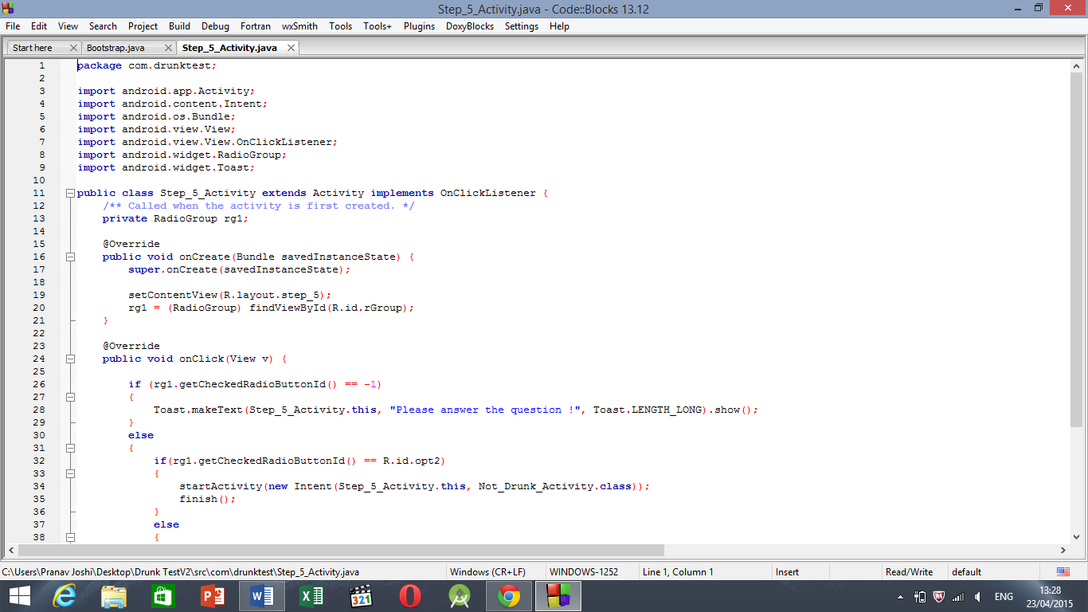

B.3 Conclusion:

Hence we have conducted demonstration of back end development.